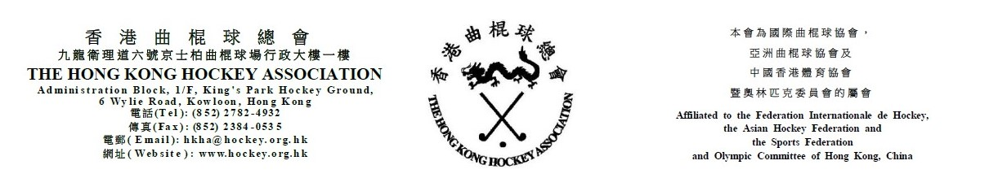

The Hong Kong Hockey Association
Annual General Meeting
31 July 2018 (Tuesday)
Nomination Form

(Please see notes below before completing the form)
I agree to be nominated for the HKHA Officer post of :- (please tick)

[ ] President
[ ] Vice President
[ ] Hon. Secretary General

______________________  Name of Nominee | ________________  Club |  | _____________________  Signature |  | ____________  Date
Proposed by:
__________________________  Name |  | _________________________  Signature |  | _________________  Date
__________________________  Club |  | _________________________  Position
Seconded by:
__________________________  Name |  | _________________________  Signature |  | _________________  Date
__________________________  Club |  | _________________________  Position

Notes: (1) To be valid, nominations must be proposed and seconded by club officials of affiliated Clubs, and agreed to by the nominee. Club officials include President, Chairman, Hon. Secretary, Convener and Hockey Section Captain.
(2) Completed nomination forms must be received by the HKHA office no later than 5:00 pm on 17 July 2018 (Tue).

